Event bridge demo and cloud watch

1 Started with creating cloud watch log and log group
Amazon CloudWatch is a monitoring and observability service provided by Amazon Web Services (AWS) for DevOps engineers, developers, and IT managers. It acts like the "eyes and ears" of your infrastructure, providing a unified view of the health and performance of your applications and resources
It has these three things.
- Log Event (The Sentence): A single record of something that happened at a specific time (e.g., "User 'John' logged in at 10:00 AM").
- Log Stream (The Page): A collection of events coming from one specific source, like a single server or one instance of a function.
- Log Group (The Folder): A container that holds multiple streams. You usually group them by application or environment (e.g., all streams for your "Payments-App" go into one group).
Step 1. Created Log group : In below screenshot there is a create log group box
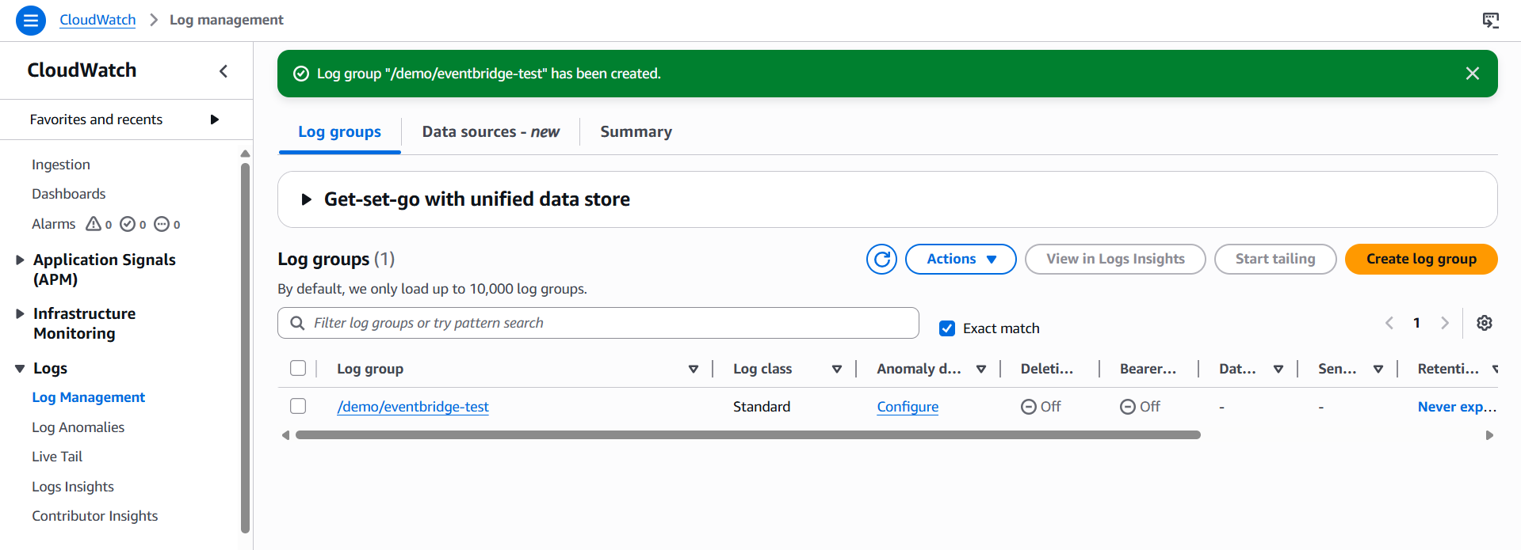
Just click that and give name and keep everything same ,
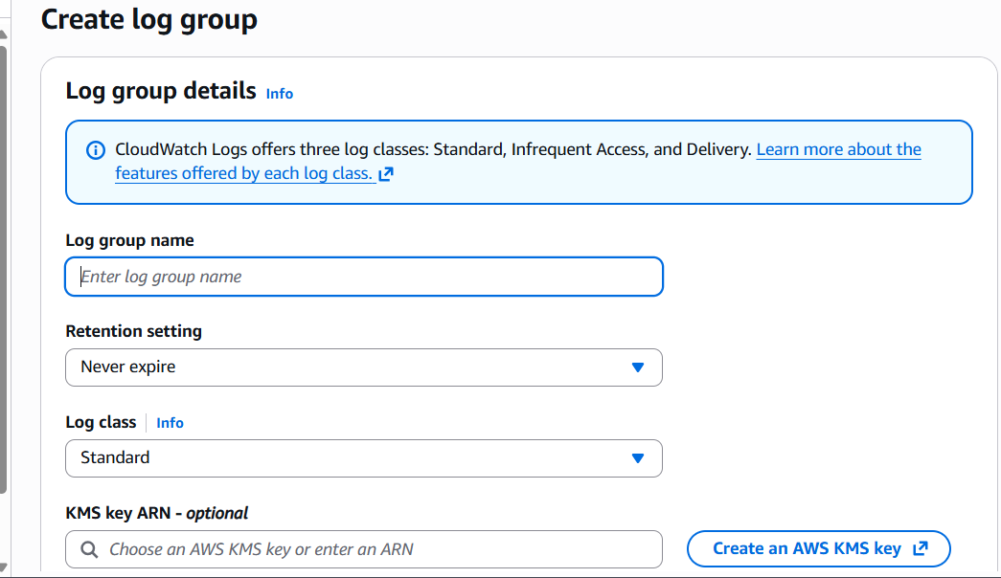
I already created one
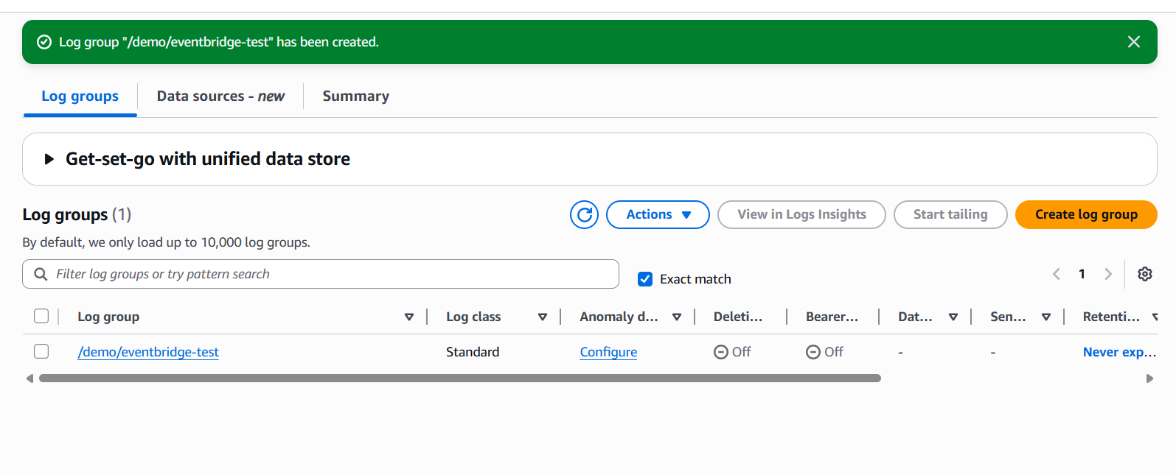
Now the second step to create an event in event bridge
- Go to event bridge → Rules
- Select Event bus → Default
- Create Rule

